**NPM ASSIGNMENT**

**NPM PACKAGE:** Set-up of NPM packages in systemwith the help of “**brew install npm”** in terminal.

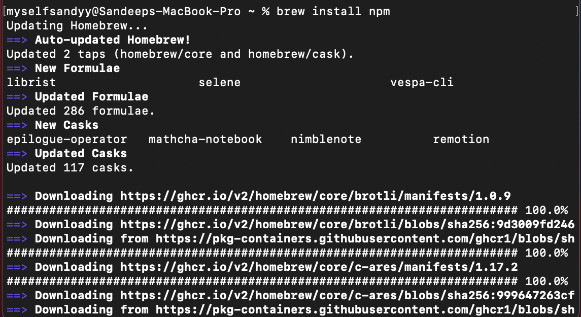

**NODE.js :** Set-up the Node.js environment by **“curl -fsSL https://deb.nodesource.com/setup_14.x | sudo -E bash -”** and after this we need **“brew install nodejs”** to install.

I also checked the NMP and NodeJs version by **“npm --version”** & **“node --version”**

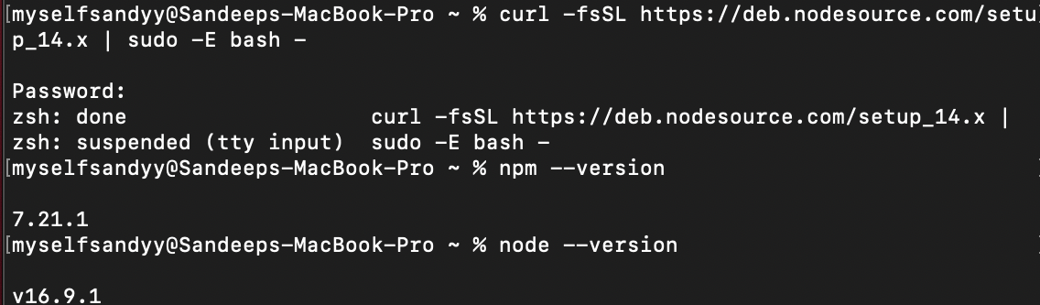

**VUE :** Set-up the Vue environment by “**sudo‌ ‌npm‌‌ install‌ ‌-g‌ ‌@vue/cli”** and checking the version by **‌“vue‌ ‌--version”‌** .

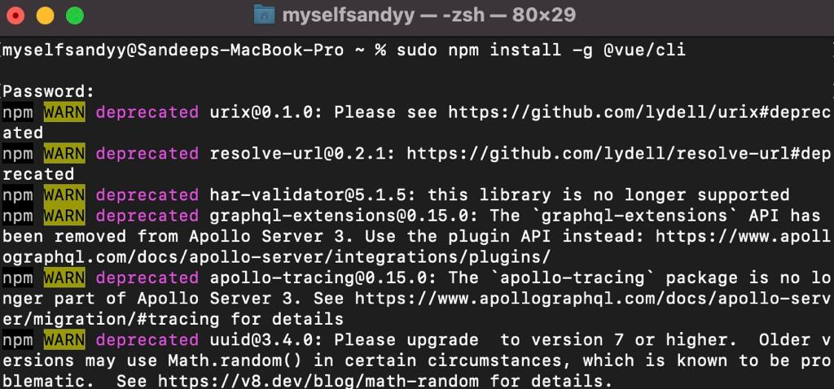

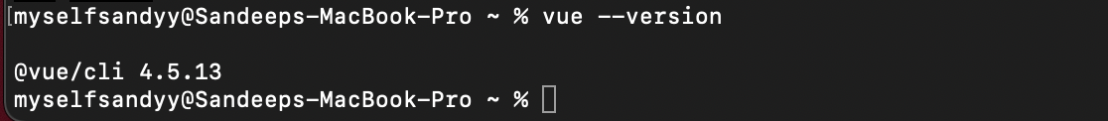

**ANGULAR :** ‌Installed‌ ‌Angular‌ ‌by‌ ‌using‌ the‌ ‌**“sudo‌ ‌npm‌‌ install‌ ‌-g‌ ‌@angular/cli”‌** ‌command and checking version by **“ng --version”** .

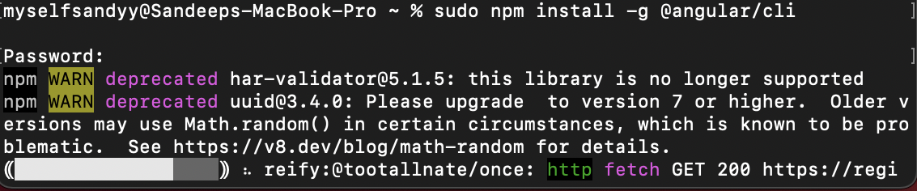

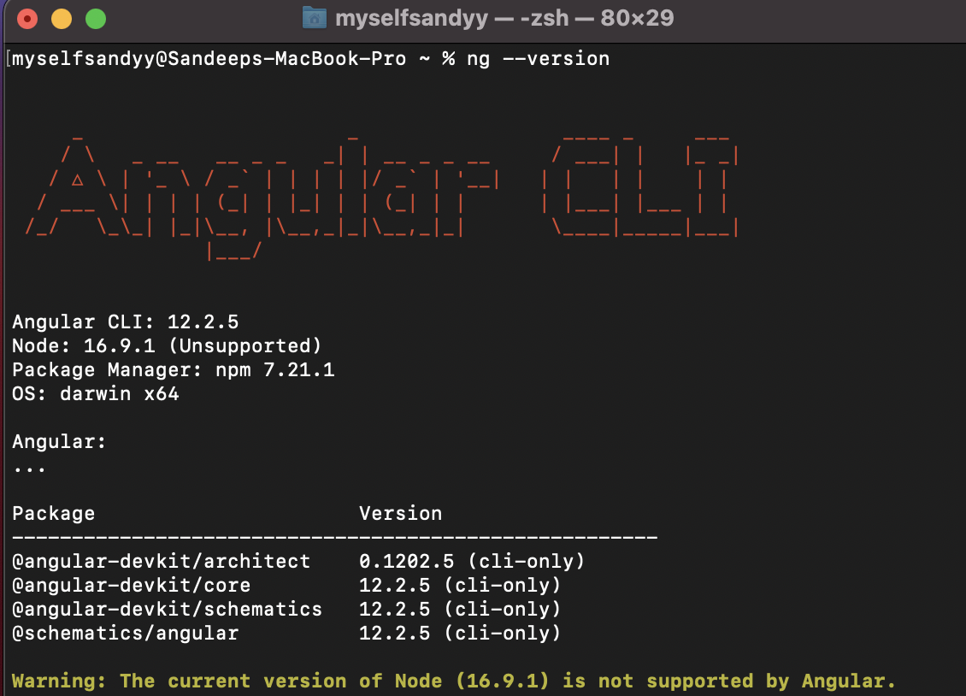

**REACT :** I‌ installed‌ ‌React‌ ‌by‌ ‌using‌ ‌**“ ‌ sudo‌ ‌npm‌ ‌-g‌ ‌install‌‌ create-react-app”‌** ‌and‌ ‌then‌ ‌I‌ ‌checked‌ ‌‌version by ‌the‌ ‌command‌ ‌**“create-react-app‌ --version”**.

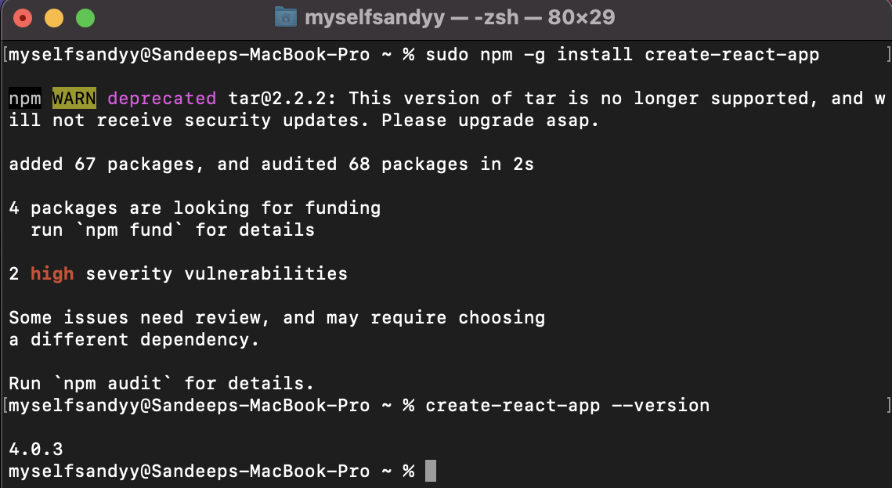

**IONIC :** Installed Ionic by using ‌**“sudo‌ ‌npm‌ install‌ ‌-g‌‌ @ionic/cli”‌** ‌and‌ ‌then‌ ‌I‌ ‌checked‌ ‌version by‌ ‌using‌ ‌the‌ command‌ ‌**“ionic‌ ‌--version”**.

